***Assignment 1***

**Create the following using Scratch:**

1. Take a text input from the user as one of the three shape names – "square", "triangle" or "pentagon". Based on the input, draw either a red square, yellow triangle or black pentagon.

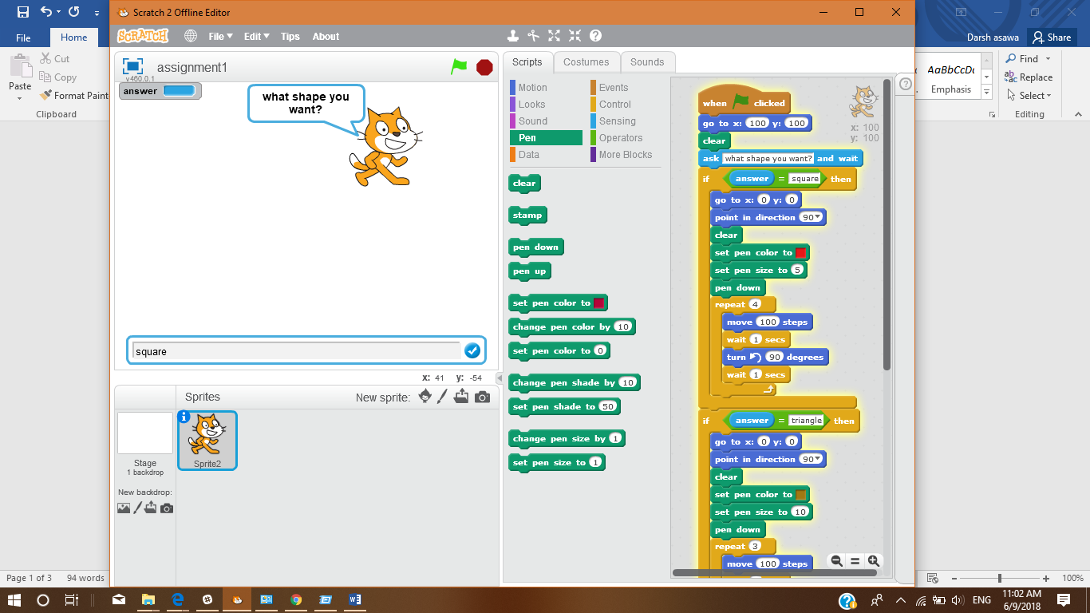

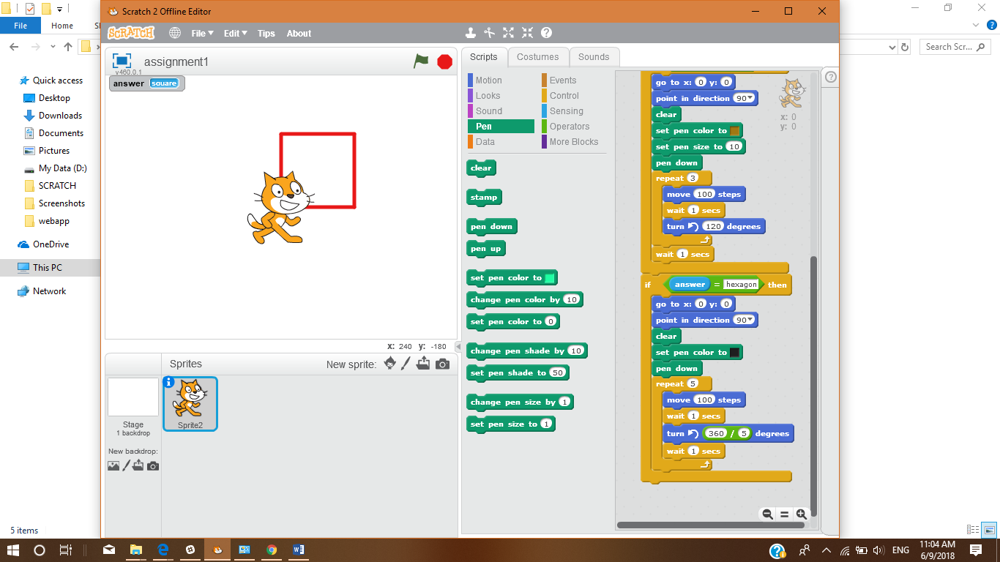

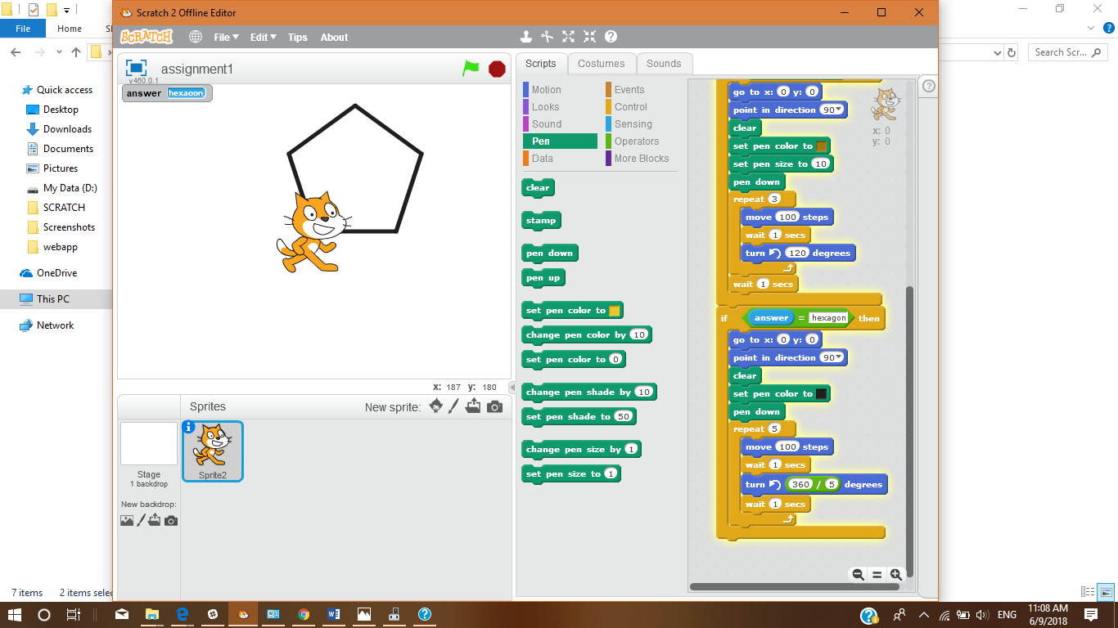

1. Create the following pattern using Scratch.

Hint: Create 10 squares each with an inclination of 36 degrees from the preceding square.

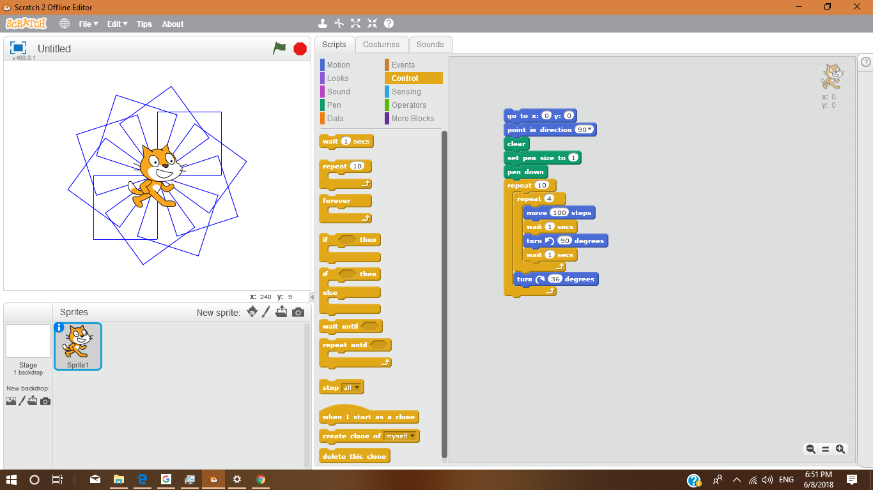

1. Create or import two Sprites and use your imagination to make them do diﬀerent actions simultaneously. For example: "A bird is ﬂying and a dog is walking at the same time."

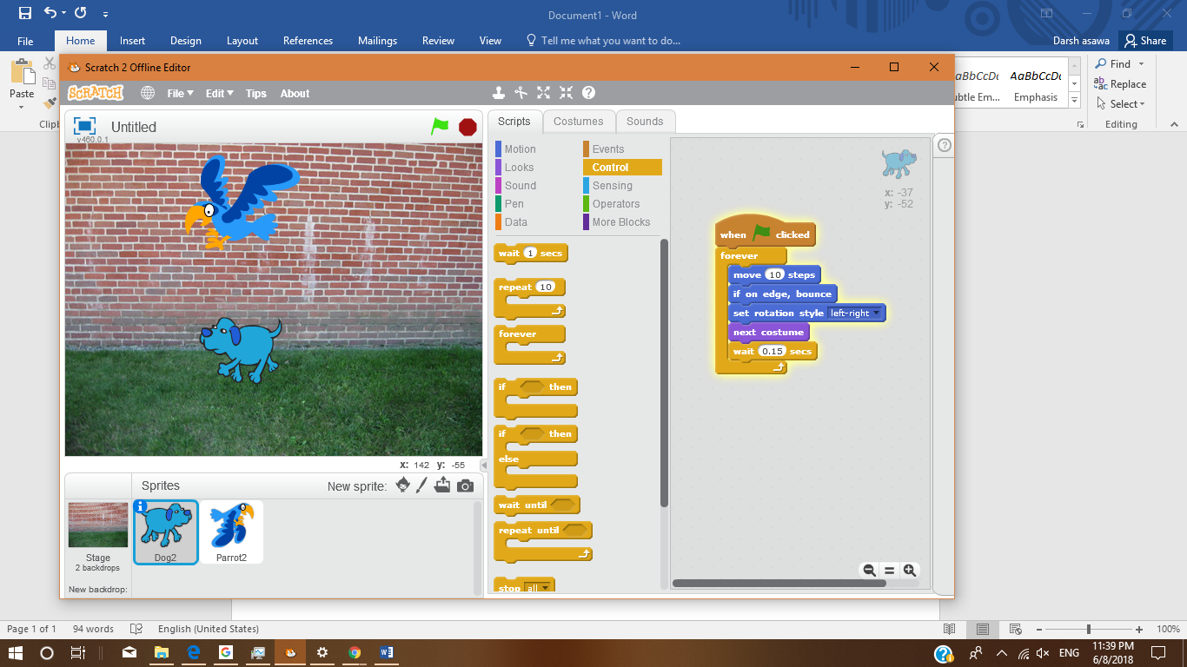

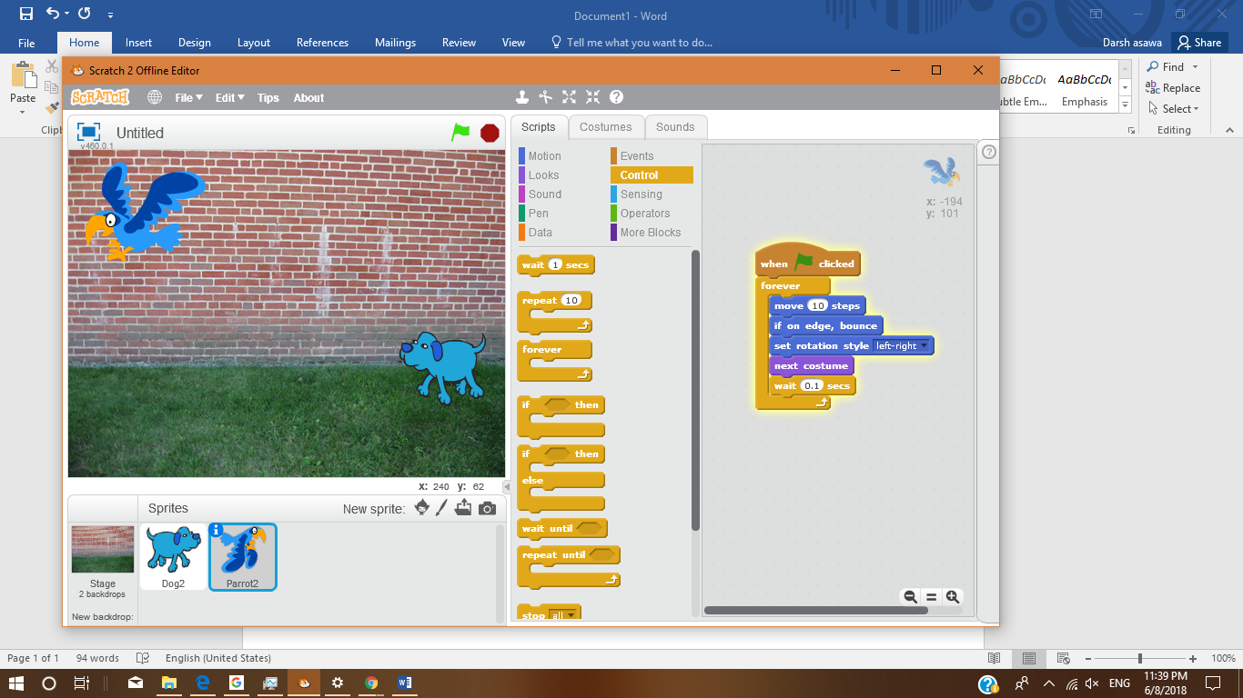

**Assignment- 2**

Create ﬂowcharts for the following problems:

1. Calculate the average of three numbers. If average is greater than or equal to 75, print "Pass", else print "Fail".

**READ A,B,C**

**D=(A+B+C)/3**

**D>75**

**Pass**

yes

No

**Fail**

2. Calculate and print the factorial of a number.

**“Enter the number:”**

**Read A**

**Count=1**

**Fact=1**

**Count>A**

No

**Fact=Fact*count**

**Count=Count+1**

3. Accept the lengths of three sides of a triangle as input from the user. Based on the input, print if the given triangle is "Equilateral", "Isosceles" or "Scalene".

**“Enter the three sides:“**

**Read A,B,C**

**If A=B OR B=C OR A=C**

**If A=B=C**

NO NO

YES YES

**Print equilateral**

**Print scalene**

**Print isosceles**

4. Accept the values of principal amount, rate of interest and number of years as an input from the user. Calculate and print the simple interest.

Hint - Formula for simple interest:

Simple Interest = (principal amount * rate of interest * number of years)/100

**Print S.I.**

**S.I.=(P*R*T)/100**

**“enter principle, rate and time (years)”**

**Read P,R,T**

------------*--------------------------*--------------------------*----------------------*----------

**ASSIGNMENT 3**

In previous section, you have created the ﬂowcharts for the following problems. Now, use Raptor tool to create and execute ﬂowcharts for these problems. Observe the output for diﬀerent set of inputs.

1. Calculate the average of three numbers. If average is greater than or equal to 75, print "Pass", else print "Fail".

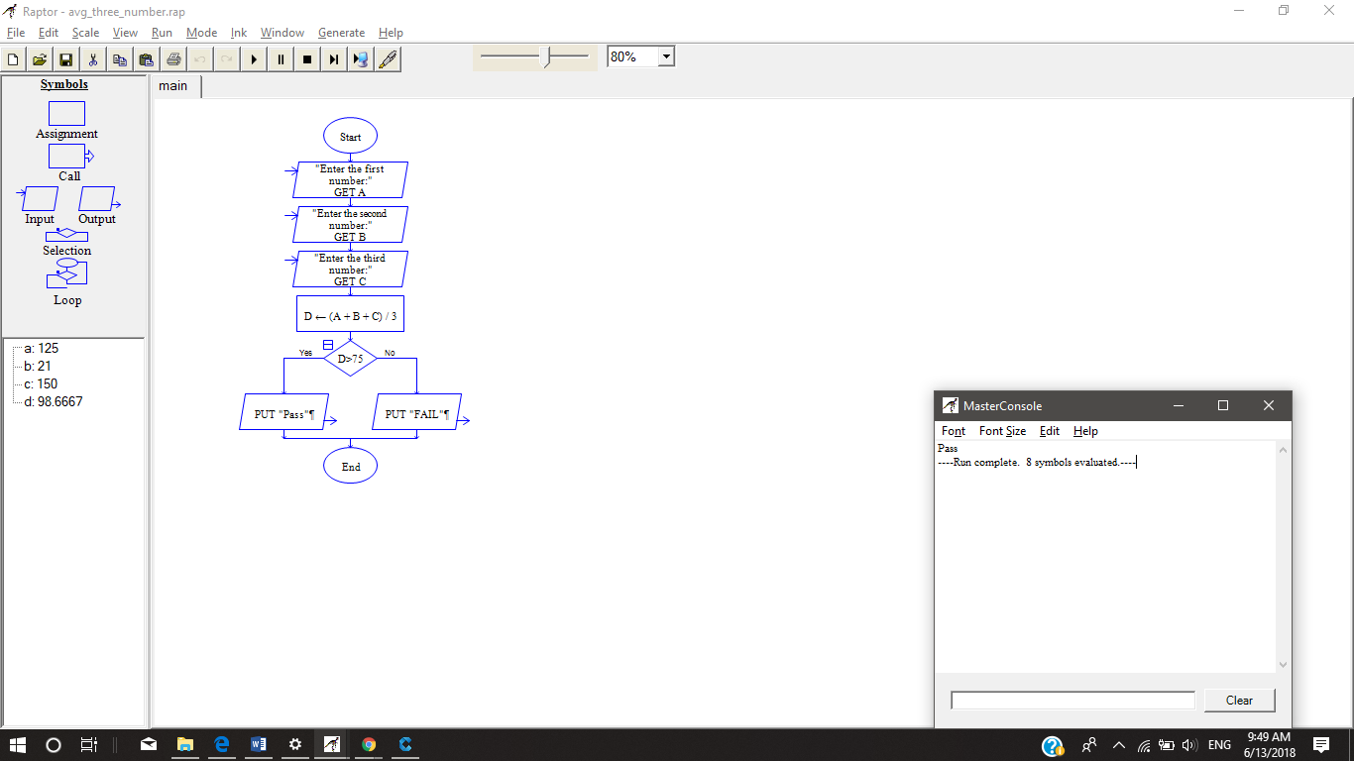

2) Calculate and print the factorial of a number.

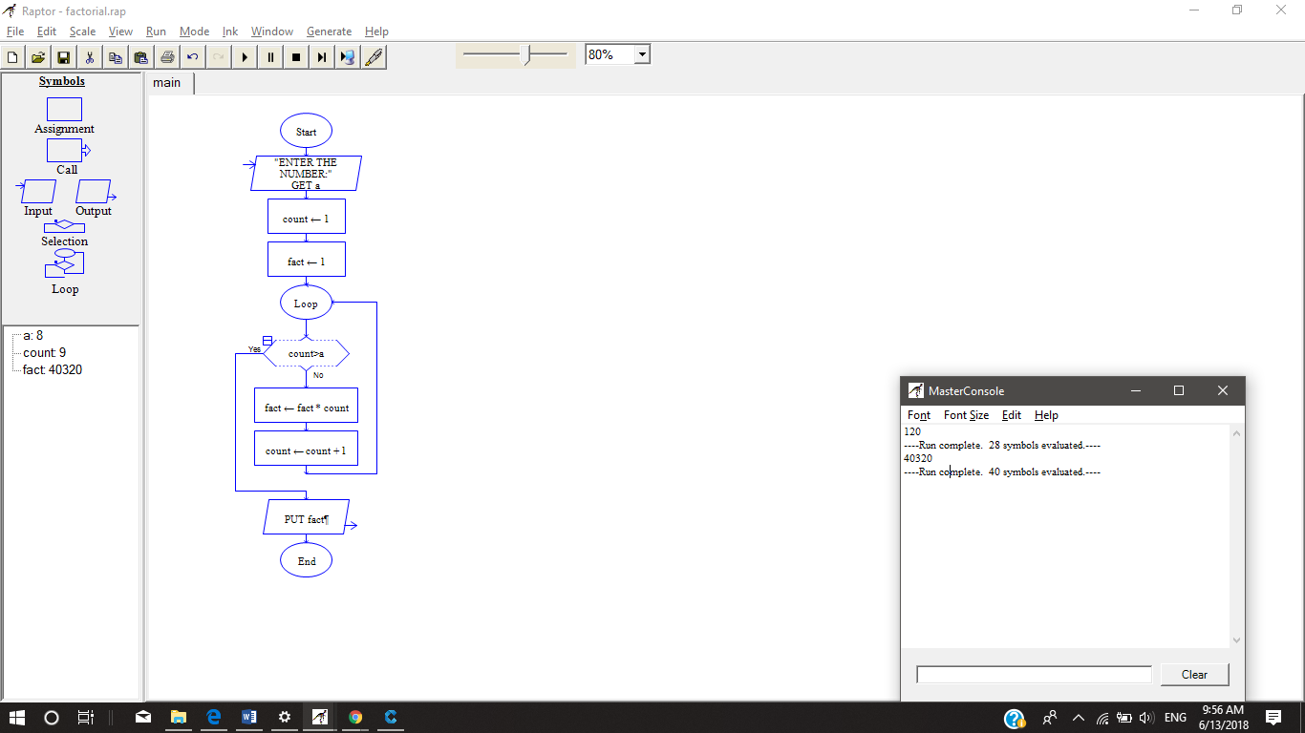

1. Accept the lengths of three sides of a triangle as input from the user. Based on the input, print if the given triangle is "Equilateral", "Isosceles" or "Scalene".

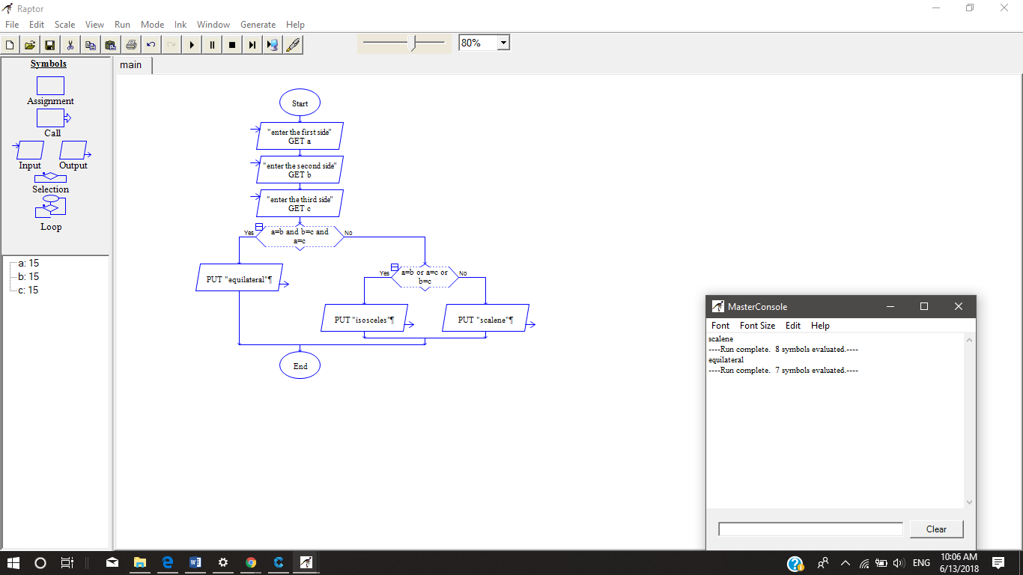

4) Accept the values of principal amount, rate of interest and number of years as an input from the user. Calculate

and print the simple interest.

Hint - Formula for simple interest:

Simple Interest = (principal amount * rate of interest * number of years)/100

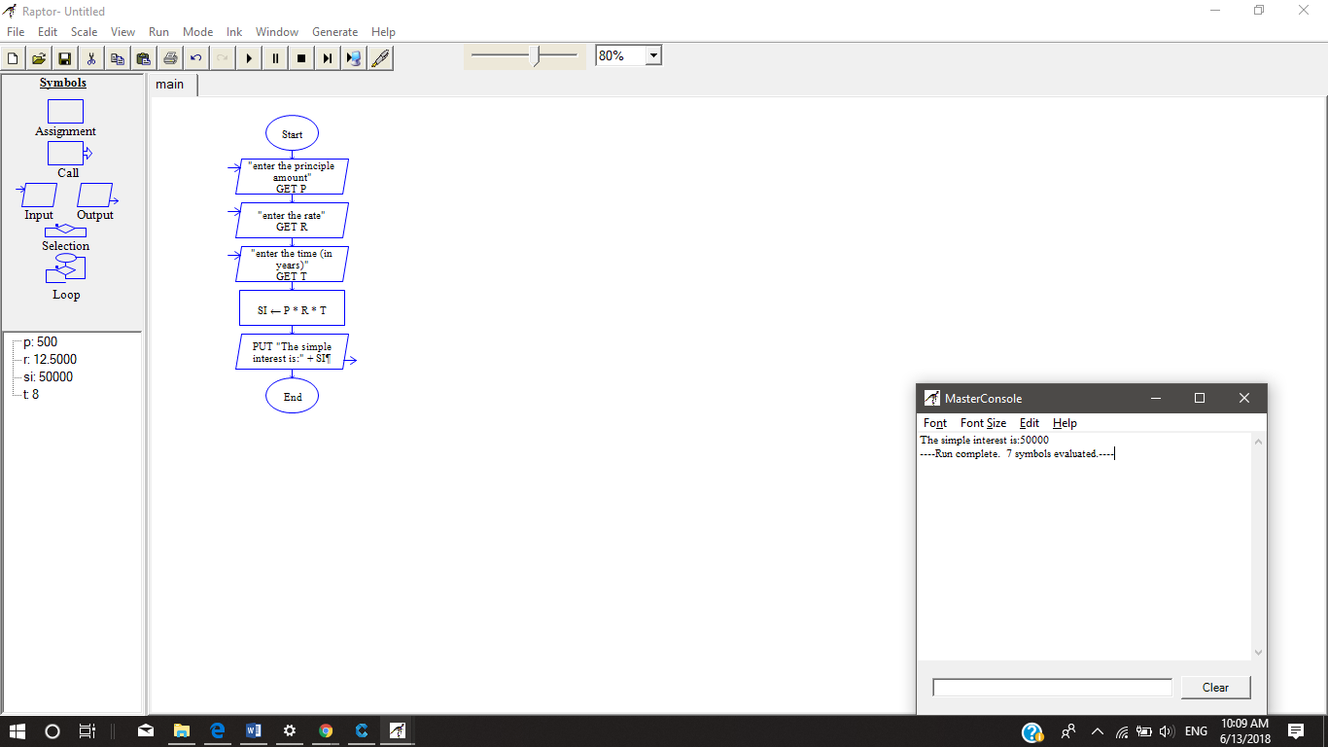

------------*--------------------------*--------------------------*----------------------*----------

**Assignment-4**

Write Pseudo Code:

1. To check whether a given number is even or odd.

Ans. **Number is even or odd**

Input N

If (n/2==0) then

Display “number is even”

Else

Display “number is odd”

End-if

1. To print the multiples of 3 between 1 to 20.

Ans. **Multiples of 3**

Set count=1

Set multiple=1

While(multiple<=20)

Set Multiple =3*count

Display multiple

Count=count+1

End-while

1. To ﬁnd factorial of a given number.

Ans. Input N

For fact=1 to N

Set factorial = factorial * fact

End-for

Display factorial

4. to calculate ‘x’ to the power of ‘n’ using a while loop.

•

Assume both ‘x’ and ‘n’ are positive whole numbers.

Ans.

Input x

Input n

While(count<=n) then

Y=y*x

And count++

End-while

Display “x to power n is y “

------------*--------------------------*--------------------------*----------------------*----------

**Assignment 5**

Open the Python IDLE and execute the following commands. Observe the output.

1) 10 + 15

2) print("Hello World")

3) 45 - 34

4) 8 * 2

5) print("Rahul's age is", 45)

6) print("I have", 10, "mangoes and”,12, "bananas")

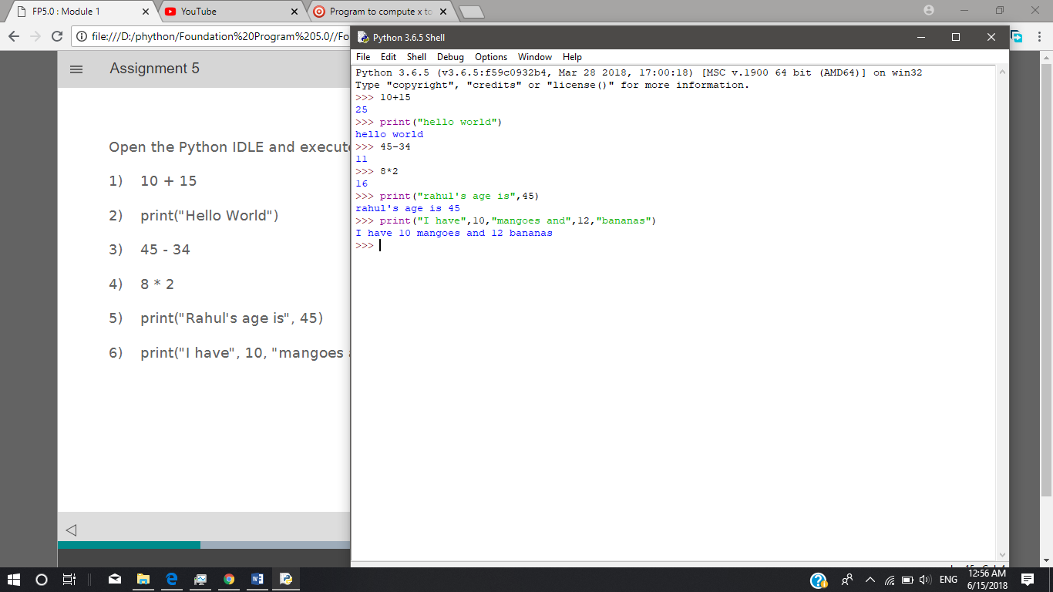

------------*--------------------------*--------------------------*----------------------*----------

**Assignment – 6**

Open Python IDLE and execute the following commands. Observe the output.

1. emp_number = 1233

2. print("Employee Number:", emp_number)

3. emp_salary = 16745.50

4. emp_name = “Jerry Squaris"

5. print("Employee Salary and Name:", emp_salary, emp_name)

6. emp_salary = 23450.34

7. print("Updated Employee Salary:", emp_salary)

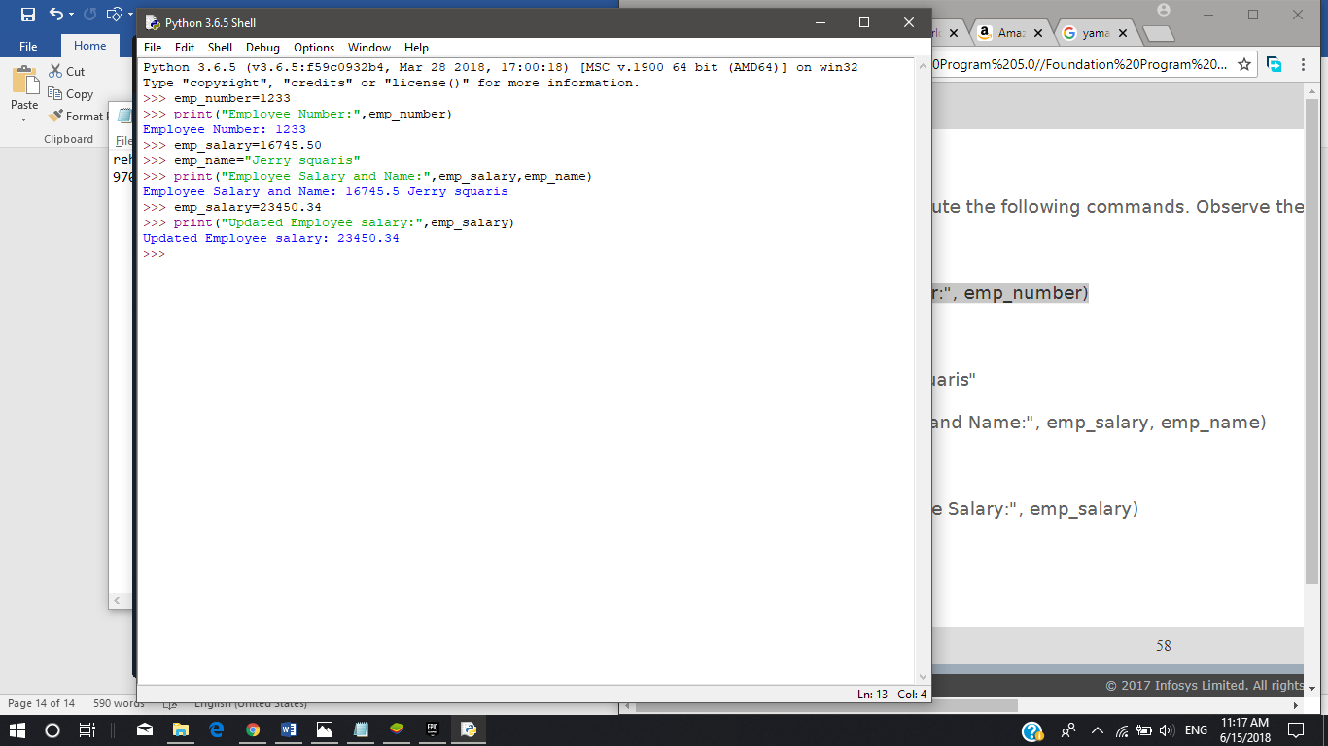

------------*--------------------------*--------------------------*----------------------*----------

**Assignment – 7**

Execute the following Python statements in IDLE and observe the output:

• customer_id = 101

• type(customer_id)

• customer_name = "John"

• type(customer_name)

• bill_amount = 675.45

• type(bill_amount )

• x = 5.3 + 0.9j

• type(x)

• print(customer_id, customer_name, bill_amount)

• print(x.real)

• print(x.imag + 3)

• Flag = True

• type(Flag)

• y = "False"

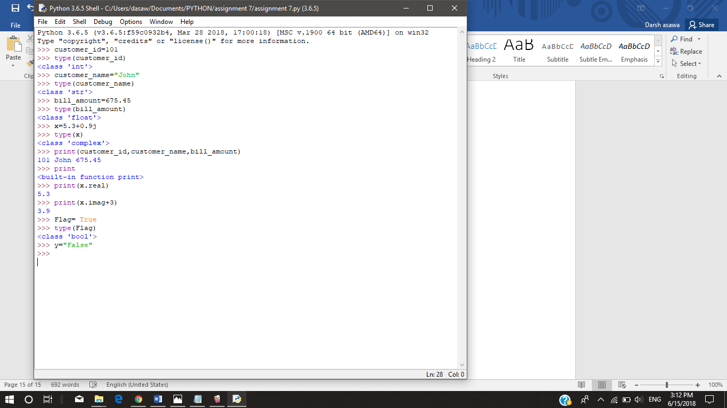

------------*--------------------------*--------------------------*----------------------*----------

**Assingment-8**

In a retail application, shopkeeper wants to keep a track of following details of a customer. Sample values are

provided.

• bill_id = 101

• customer_id = 1001

• customer_name = "Rahul"

• if_minor = False

• bill_amount = 2000.50

Write a python program to store the details and display them

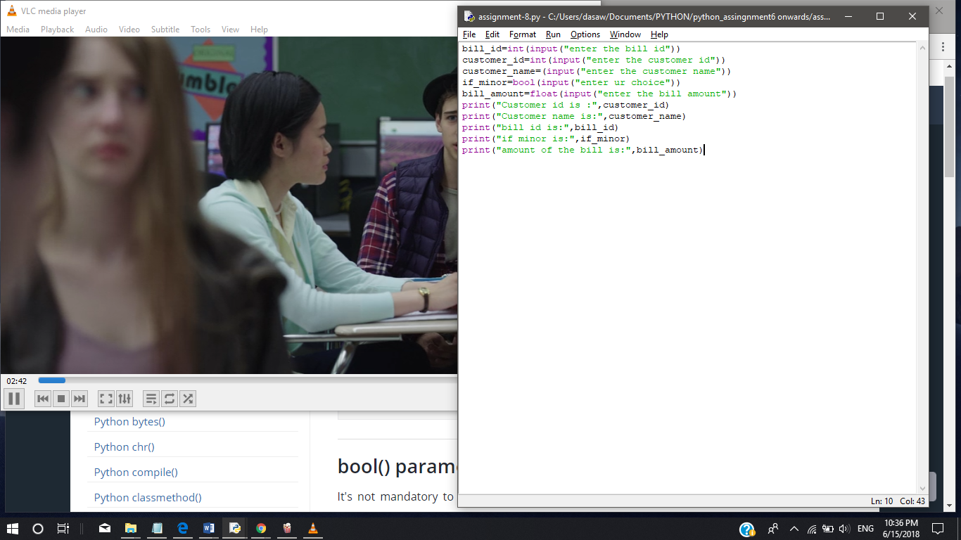

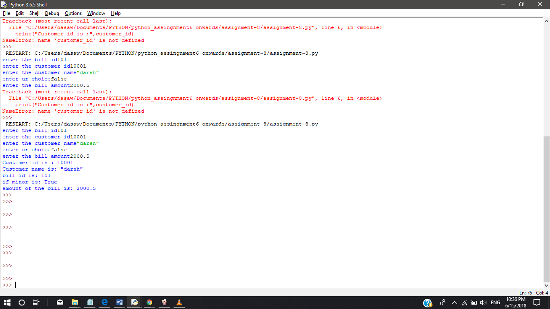

------------*--------------------------*--------------------------*----------------------*----------

**Assignment-9**

Execute the following commands and observe the usage of diﬀerent types of commenting styles.

i = 10

# creates an integer variable. This is a single line comment.

print("i =", i)

# prints 10

'''

Below code creates a Boolean variable in Python

(This is a multiple line comment)

'''

s = True

print("s =", s)

#prints True, Here, s is a Boolean variable with value True

"""

Below code assigns string data to variable 's'. Data type of variable can change during execution,

Hence, Python supports Dynamic Semantics.

(This is multi-line comment used for documentation)

"""

s = 24

print("s =", s)

#prints 24, Here, s is changed to integer data type with value 24

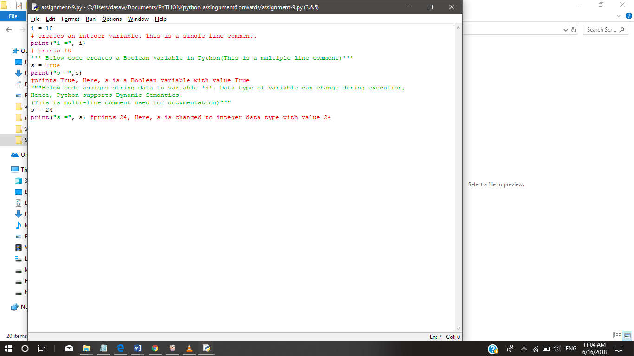

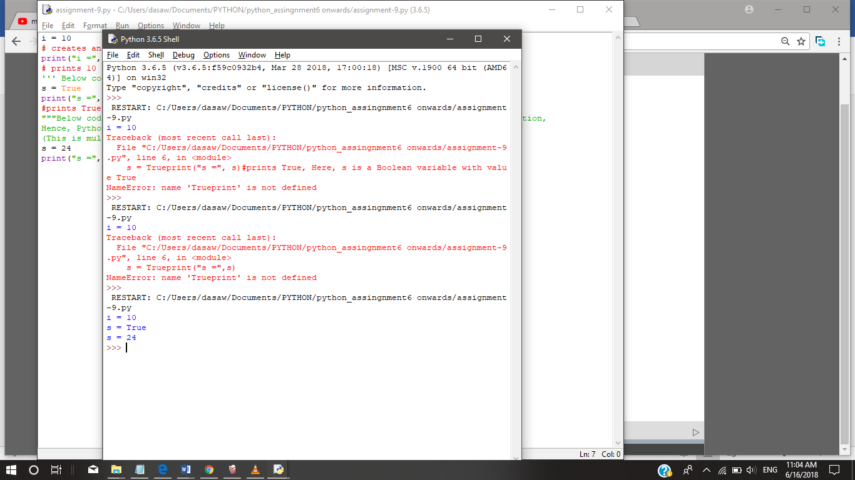

600011489404

------------*--------------------------*--------------------------*----------------------*----------

**Assignment -10**

Write a Python program for the following requirements:

• Prompt the user to input two numbers num1 and num2

• Increment num1 by 4 and num2 by 6

• Find and print the sum of new values of num1 and num2

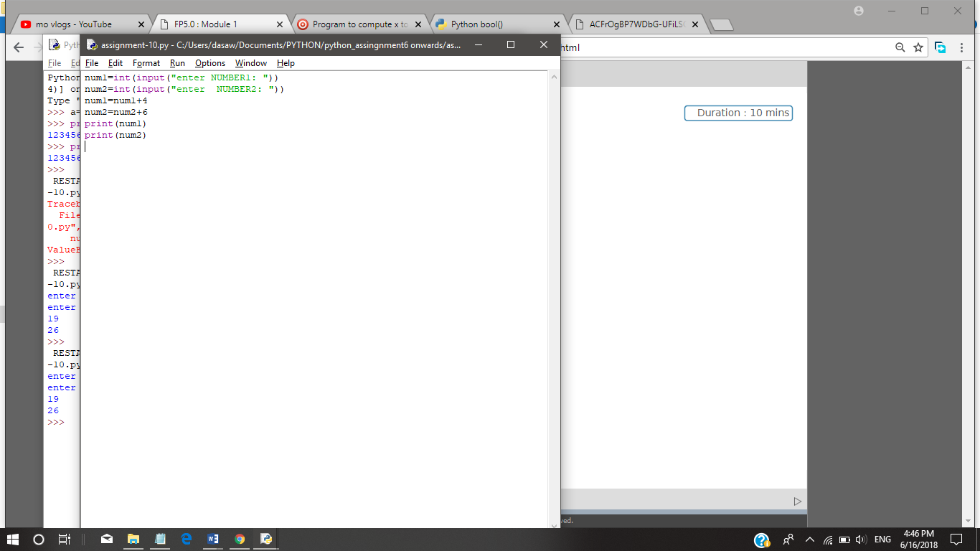**\**

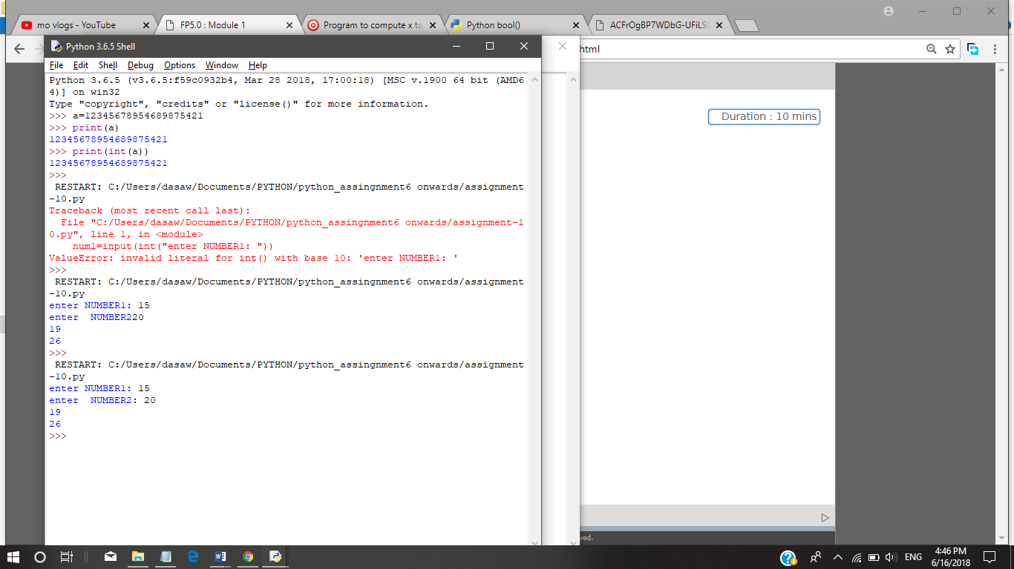

------------*--------------------------*--------------------------*----------------------*----------

**Assignment-11**

1. Consider two variables 'a' and 'b' in Python such that a = 4 and b = 5. Swap the values of 'a' and 'b' without using a temporary variable. Print the values of 'a' and 'b' before and after swapping.

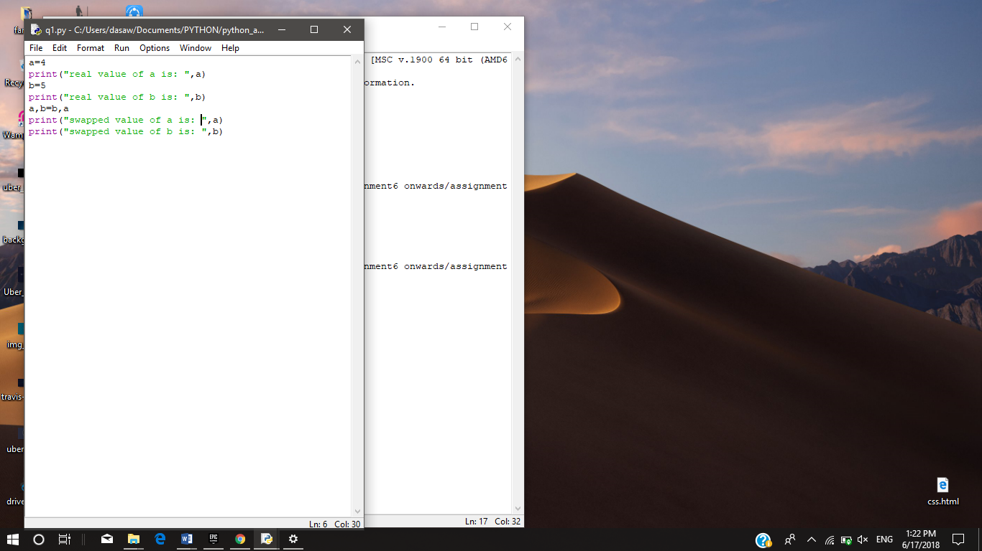

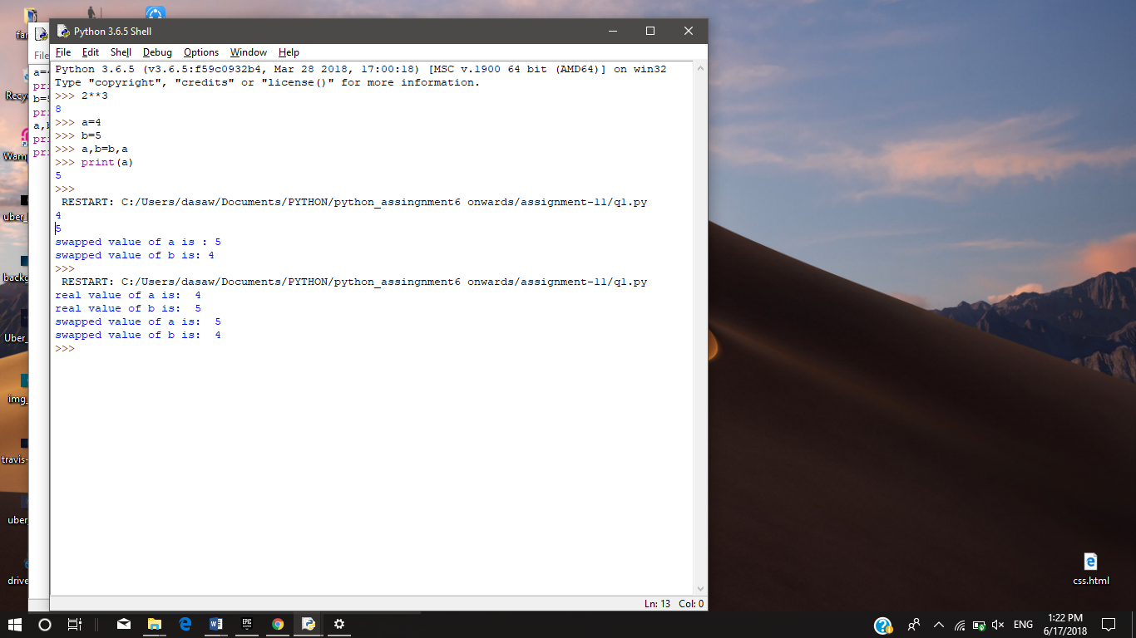

1. Consider the scenario of processing marks of a student in ABC Training Institute. John, the student of ﬁfth grade takes exams in three diﬀerent subjects. Create three variables to store the marks obtained by John in three subjects. Find and display the average marks scored by John.

Now change the marks in one of the subjects and observe the output. Did the value of average change?

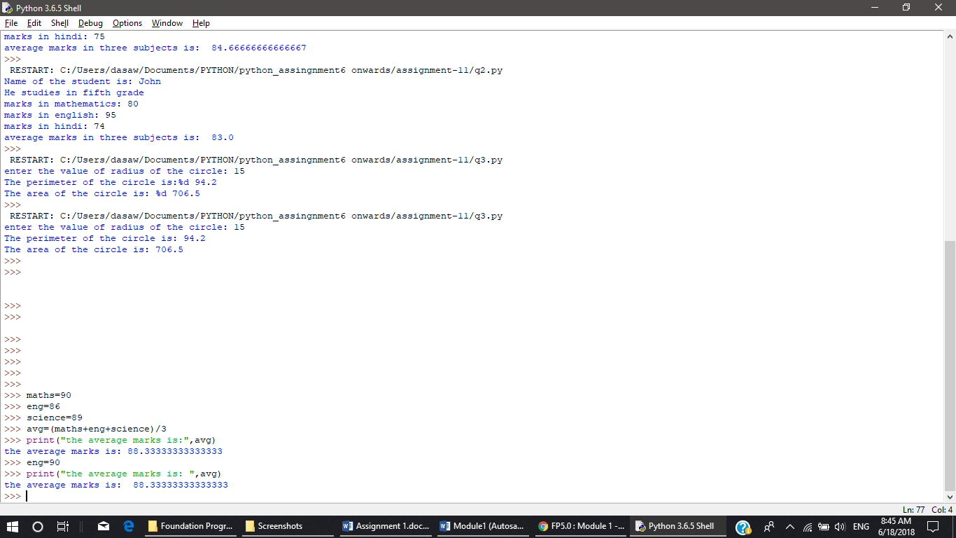

No, the value of average marks doesn’t change by changing the marks of one subject i.e. English here

3) Given the value of radius of a circle, write a Python program to calculate the area and perimeter of the circle.

Display both the values.

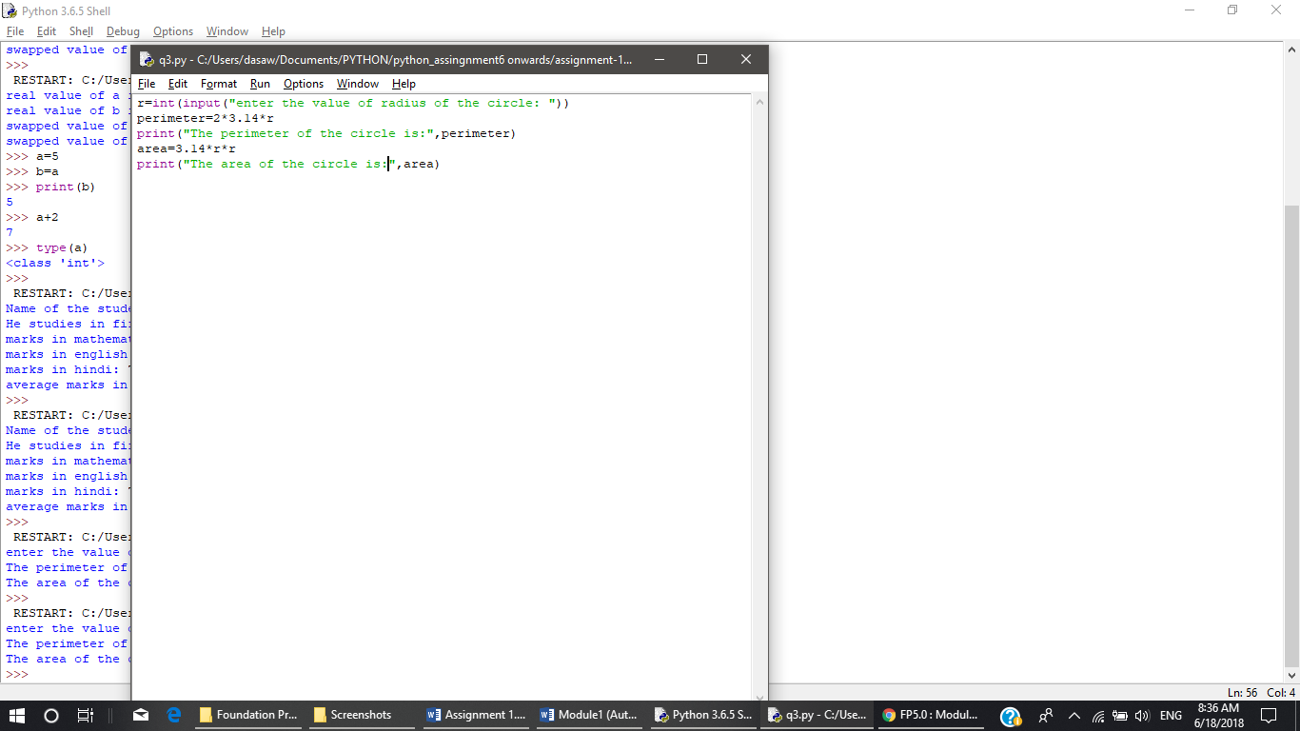

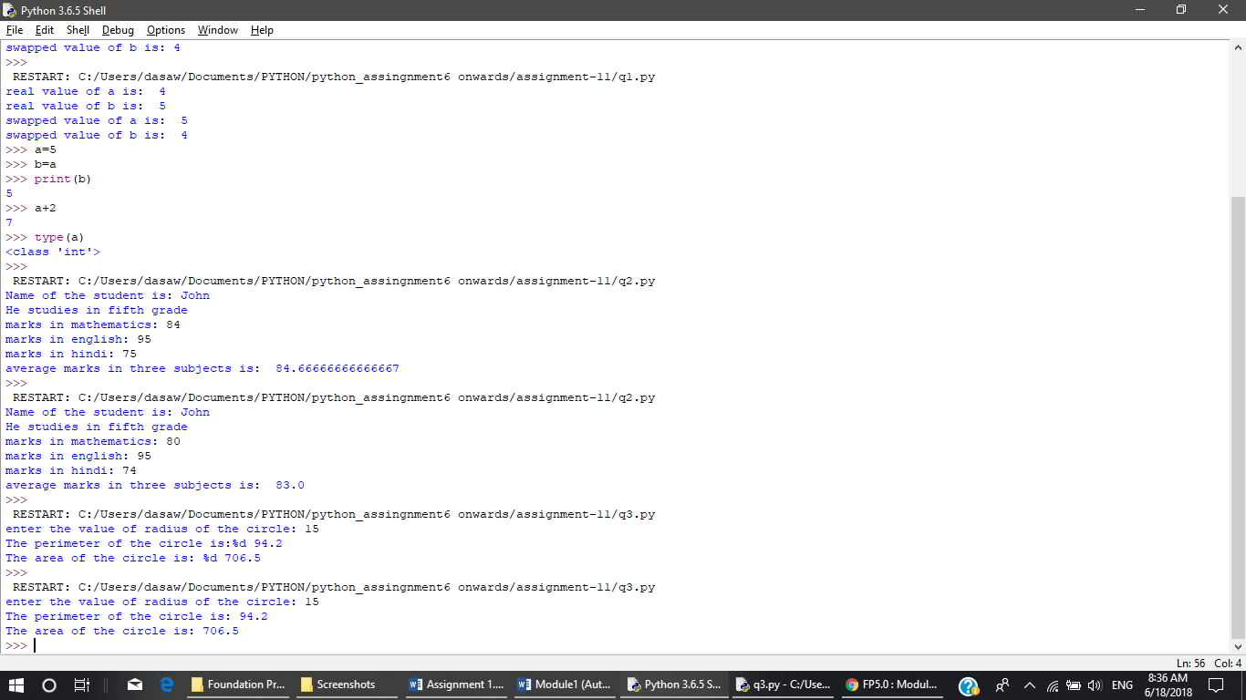

4) The ﬁnance department of a company wants to compute the monthly pay of its employees. Monthly pay should be calculated as mentioned in the formula below. Display all the employee details.

Monthly Pay = Number of hours worked in a week * Pay rate per hour * No. of weeks in a month

• The number of hours worked by the employee in a week should be considered as 40

• Pay rate per hour should be considered as Rs.400

• Number of weeks in a month should be considered as 4